| Software design |
| --- |
| Train booking System |
| Version 1.0.4 |
| Prepared by class SE1735, Group 4  Phạm Quang Thắng  Phạm Hoàng Tùng Nguyễn Thế Anh Trường  Đồng Trung Hiếu  Nguyễn Văn Đạt  Oct 27, 2023 |

Lecturer: Nguyễn Thúy Hường

Class SE1735_Net  
Group 4

**Contents**

**Revision history** **5**

**1. Document description** **6**

**2. SRS overview** **6**

2.1. List of system users 6

2.2. List of use cases 6

2.3. Use case diagram 7

2.3.1. Preliminary use case diagram 7

2.3.2. Use case detail diagrams 7

2.3.2.1. Use case “Book Trains Ticket” 7

2.3.2.2. Use case “Cancel Ticket” 8

2.3.2.3. Use case “VIew Ticket Details” 8

2.3.2.4. Use case “Check Train Schedule” 8

2.3.2.5. Use case “Add Ticket” 8

2.4. Activity diagrams of use case scenarios 9

2.4.1. Activity diagram for use case “Book Trains Ticket” 9

2.4.2. Activity diagram for use case “Cancel Trains Ticket” 10

2.4.1. Activity diagram for use case “Add Ticket” 10

**3. Data model** **11**

3.1. Entity Relationship Diagram 11

3.2. Table details/Chi tiết các bảng 11

3.2.1. Table name: Ticket 11

3.2.2. Table name: Train 12

3.2.3. Table name: Wagon 12

3.2.4. Table name: Bookings 12

3.2.5. Table name: Type 12

3.2.6. Table name: Ticket_Class 13

**4. Class diagram (p.61 – p70)** **14**

4.1. List of classes in the Layers 14

4.2. Modeling the Class Behaviors - sequence diagrams ( p. 66, 77) 14

4.2.1. Sequence diagram for use case “Borrow copy” 15

4.2.2. Sequence diagram for use case “Return copy” 16

4.2.3. Sequence diagram for use case “Reserve Book” 17

**5. User Interface Model Design (p. 70 – p.74)** **18**

5.1. User interface model design 18

51.1. Screen “Register books” 18

51.2. Screen “Register members” 18

51.3. Screen “Borrow books” 19

51.4. Screen “Return books” 19

51.5. Screen “Reserve books” 20

5.2. Interface Flow Diagrams (p. 51) 20

# Revision history

| **Date** | **Authors** | **Modifications** | **Version** |
| --- | --- | --- | --- |
| 25/10/2023 | Phạm Quang Thắng | Create Documents | 1.0.1 |
| 26/10/2023 | Phạm Hoàng Tùng | Create Section 1 , Section 2 | 1.0.2 |
| 27/10/2023 | Phạm Hoàng Thắng,  Nguyễn Văn Đạt | Create Section 3 , Section 4 | 1.0.3 |
| 28/10/2023 | Phạm Hoàng Tùng | Create Section 5 | 1.0.4 |

# 1. Document description

This document describes OO solution version 1.0 for the Train booking system. It is divided into the following sections:

* In section 2 an overview of the Train booking system’s requirements will be provided, including a list of system users, use cases, use case diagrams, and activity diagrams that describe the most important use case scenarios.
* In section 3 an E-R diagram and all tables of the Train booking system in detail will be presented.
* In section 4 all classes organized in the layers and their behaviors (sequence diagrams) for the most important use cases will be presented.
* In section 5 the most screen prototypes will be presented.

# 2. SRS overview

## 2.1. List of system users

1. Admin: The person is working in the Train booking room

2.Passenger: The person uses services of the Train booking system

## 2.2. List of use cases

1. Login

2. Register

3. Book Trains Ticket

4. Cancel Trains Ticket

5. View Ticket Details

6. View Trains Schedule

7. Add/Delete/Update Trains Schedule

## 2.3. Use case diagram

### 2.3.1. Preliminary use case diagram

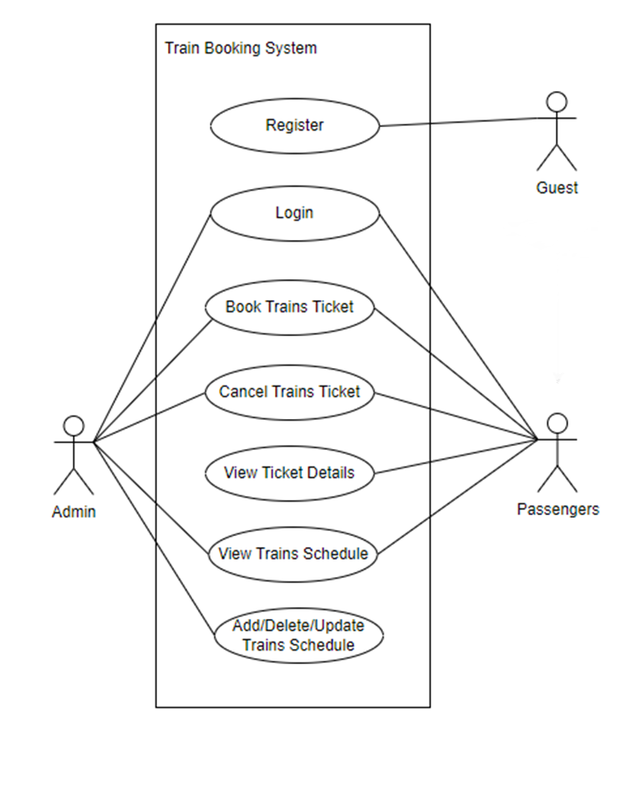

### 2.3.2. Use case detail diagrams

#### 2.3.2.1. Use case “Login”

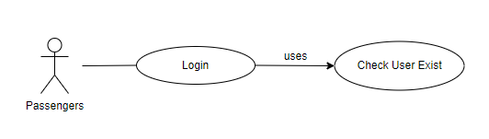

#### 2.3.2.2. Use case “Register”

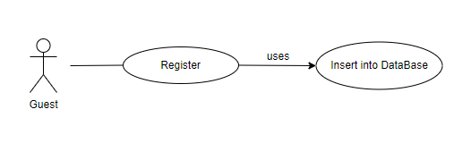

#### 2.3.2.3. Use case “Book Trains Ticket”

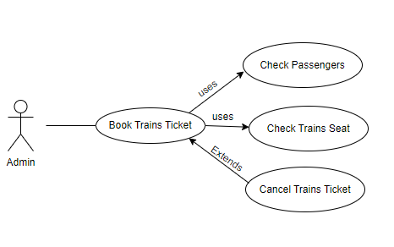

#### 2.3.2.4. Use case “Cancel Trains Ticket”

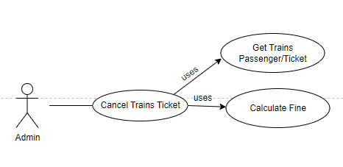

#### 2.3.2.5. Use case “VIew Ticket Details”

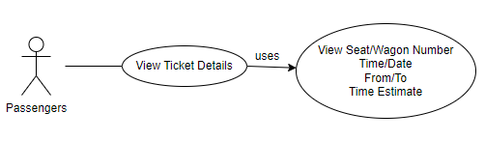

#### 2.3.2.6. Use case “View Train Schedule”

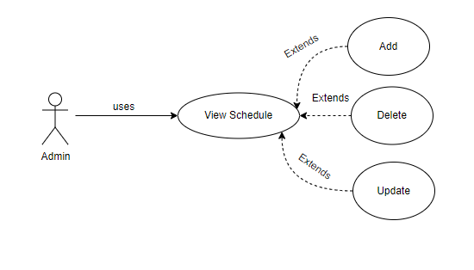

#### 2.3.2.5. Use case “Add/Delete/Update Trains Schedule”

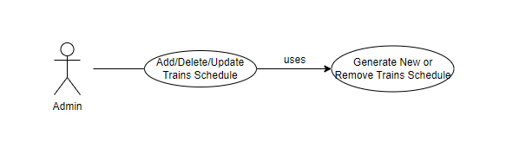

## 2.4. Activity diagrams of use case scenarios

### 2.4.1. Activity diagram for use case “Book Trains Ticket”

Get Train From/To and Slot

Get Wagon Type

Get Seat

Get Ticket (Update Ticket Into Server)

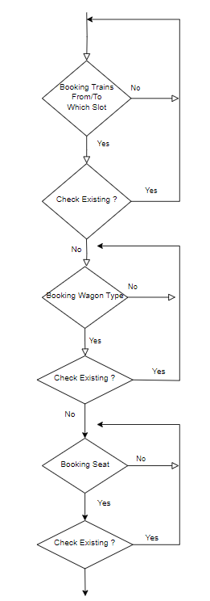

### 

### 2.4.2. Activity diagram for use case “Cancel Trains Ticket”

Get Ticket Code

Check if it exist

Calculate Fine Amount

Return (The seat will be deleted if cancel successfully)

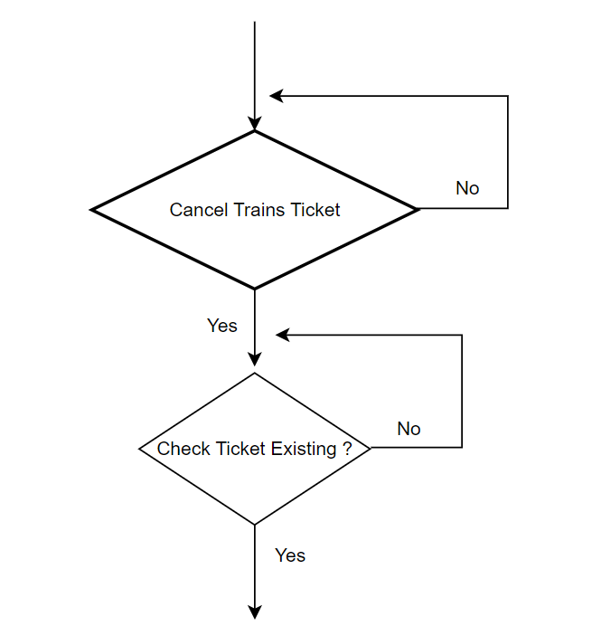

### 2.4.1. Activity diagram for use case “Add Trains Schedule”

Select the new Schedule

Set the new Trains Schedule

Update Into Server

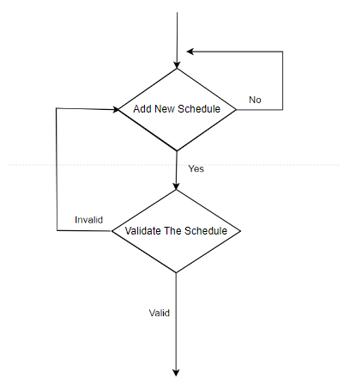

# 3. Data model

## 3.1 Entity Relationship Diagram

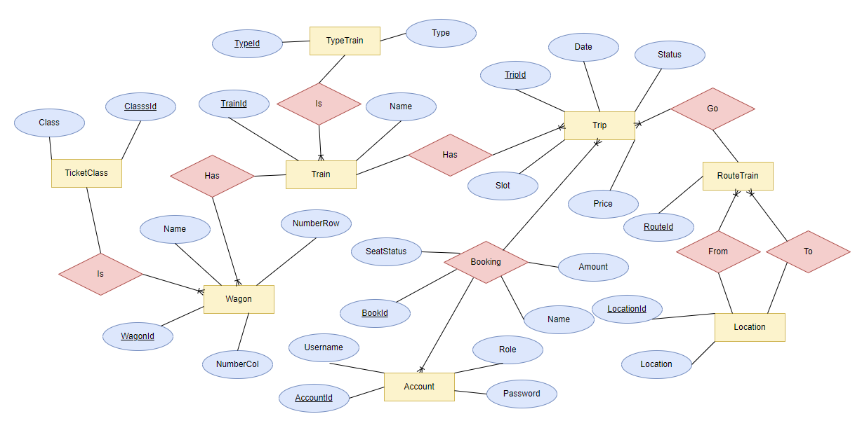

## 3.2 Table details

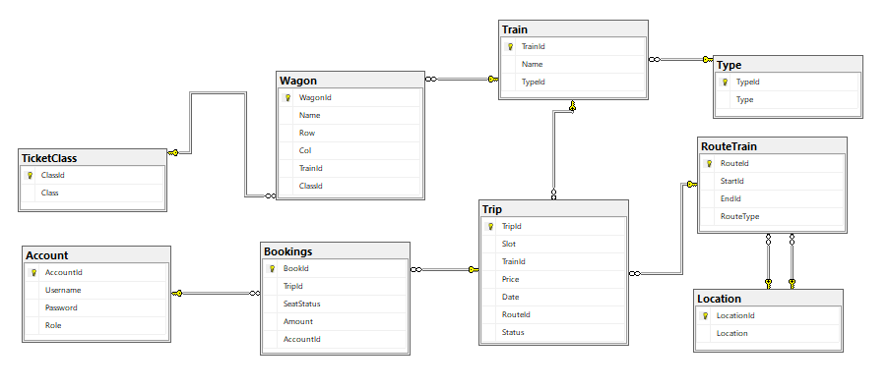

### 3.2.1 Table name: Trip

| **Field name** | **Type** | **Note** |
| --- | --- | --- |
| TripId | int | Primary key |
| Slot | int | Slots start at 0:00 PM, each slot is 2 hour apart |
| RouteId | int | Foreign key, refers to Route table (RouteId) |
| Status | bin | Status of whether tickets are still available or sold out for that trip (0 is sold out and 1 is avaiable) |
| TrainnId | int | Foreign key, refers to Train table |
| Price | money | Prices are based on train type, class of wagon and distance traveled |
| Date | date | Day of the trip |

### 3.2.2 Table name: Train

| **Field name** | **Type** | **Note** |
| --- | --- | --- |
| TrainId | int | Primary key |
| Name | nvarchar(100) | Train code and train name |
| TypeId | int | Foreign key, refers to Type table |

### 3.2.3 Table name: Wagon

| **Field name** | **Type** | **Note** |
| --- | --- | --- |
| WagonId | int | Primary key |
| Name | nvarchar(100) | Train car code |
| Row | int | Number of rows of seats in a train |
| Col | int | Number of columns of seats in a train |
| TrainId | int | Foreign key, refers to Train table |
| ClassId | int | Foreign key, refers to Ticket_Class table |

### 3.2.4 Table name: Bookings

| **Field name** | **Type** | **Note** |
| --- | --- | --- |
| BookId | int | Primary key |
| TriptId | int | Foreign key, refers to Ticket table (TicketId) |
| AccountId | int | Foreign key, refers to Account table (AccountId) |
| SeatStatus | nchar(100) | Status of seat |
| Amount | float | Total amount of tickets purchased |

### 3.2.5 Table name: TypeTrain

| **Field name** | **Type** | **Note** |
| --- | --- | --- |
| TypeId | int | Primary key |
| Type | nvarchar(100) | Type of the train |

### 3.2.6 Table name: TicketClass

| **Field name** | **Type** | **Note** |
| --- | --- | --- |
| ClassId | int | Primary key |
| Class | nvarchar(100) | Ticket class of each train car |

### 3.2.7 Table name: RouteTrain

### 

| **Field name** | **Type** | **Note** |
| --- | --- | --- |
| RouteId | int | Primary key |
| StartId | int | Foreign key, refers to Location table (LocationId) |
| EndId | int | Foreign key, refers to Location table (LocationId) |
| RouteType | int | Type of route, which will affect price of trip |

### 

### 3.2.8 Table name: Location

### 

| **Field name** | **Type** | **Note** |
| --- | --- | --- |
| LocationId | int | Primary key |
| Location | nvarchar(100) | Locations included in the trip |

### 

### 3.2.9 Table name: Account

### 

| **Field name** | **Type** | **Note** |
| --- | --- | --- |
| AccountId | int | Primary key |
| Username | nvarchar(100) | Username of this account |
| Password | nvarchar(100) | Password of this account |
| Role | bit | Role of this account (0 is user and 1 is admin) |

### 

# 4. Class diagram (p.61 – p70)

## 4.1 List of classes in the Layers

## 

## 

## 

## 4.2 Modeling the Class Behaviors - sequence diagrams ( p. 66, 77)

### 4.2.1 Sequence diagram for use case “Booking Train”

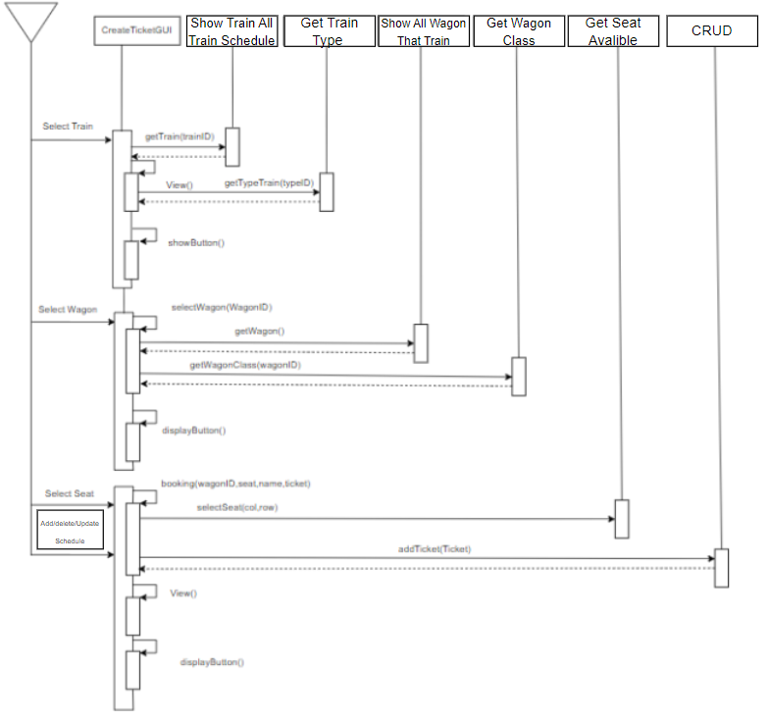

### 

# 5. User Interface Model Design (p. 70 – p.74)

## 5.1 User interface model design

### 5.1.1. Screen “Main”

* Users Screen

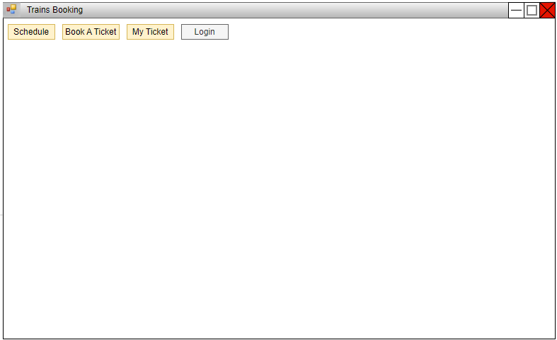

* Admin Screen

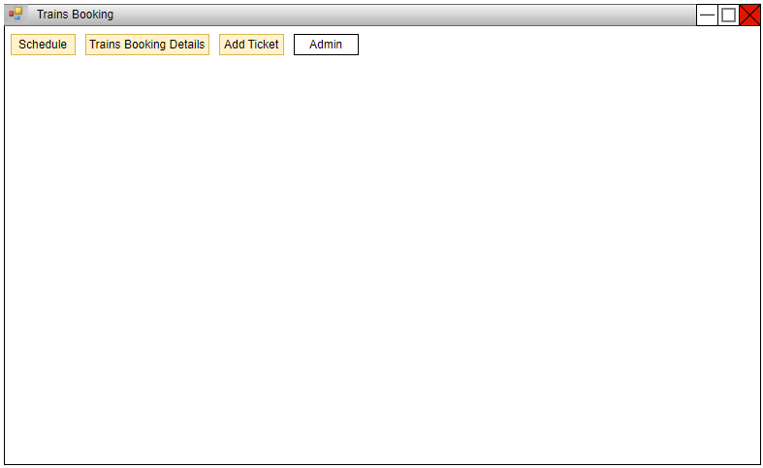

### 5.1.2. Screen “Login”

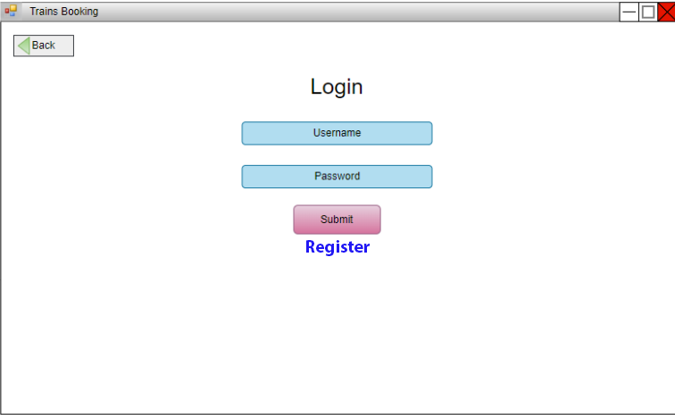

### Screen “Register”

### 5.1.3. Screen “Add Ticket”

* Admin’s Screen

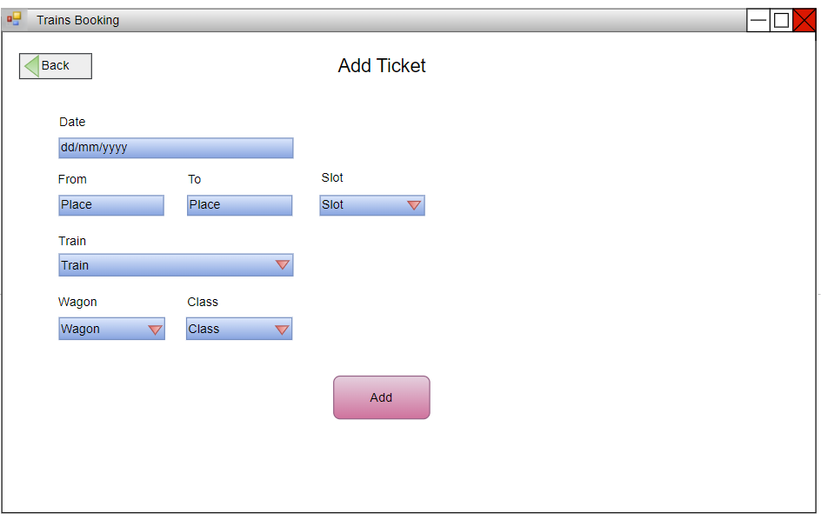

### 5.1.4. Screen “Trains Schedule”

* Users Screen

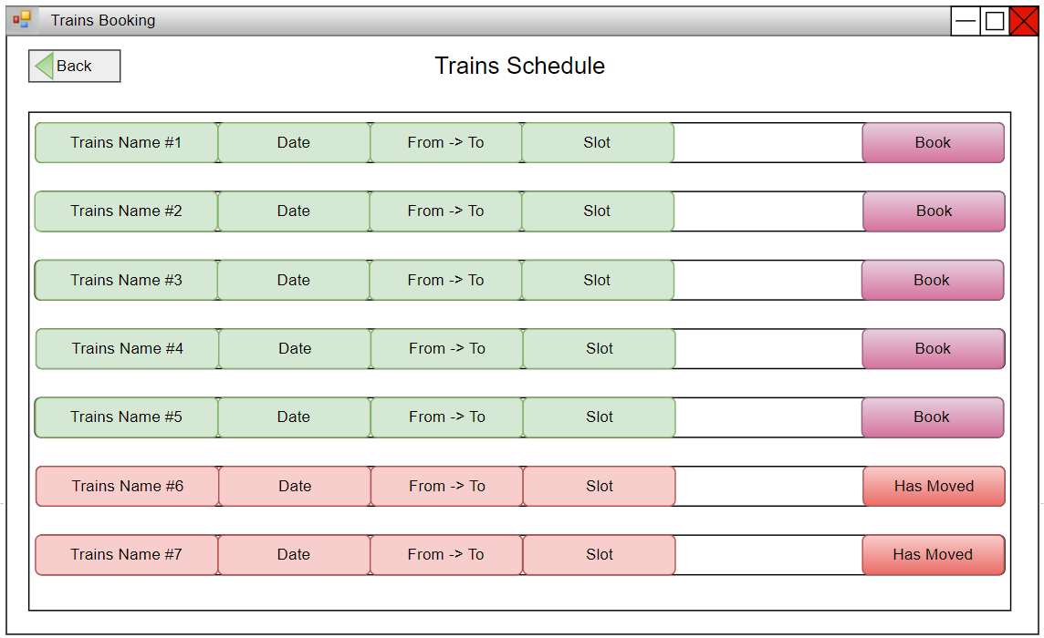

* Admin’s Screen

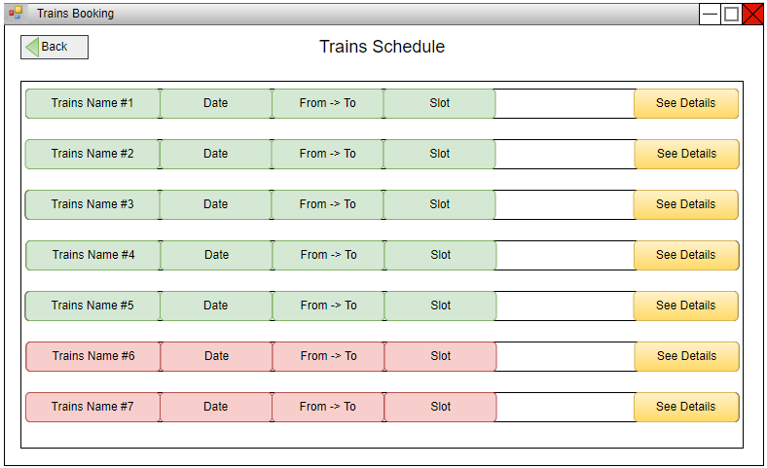

### 5.1.5. Screen “Book Wagon”

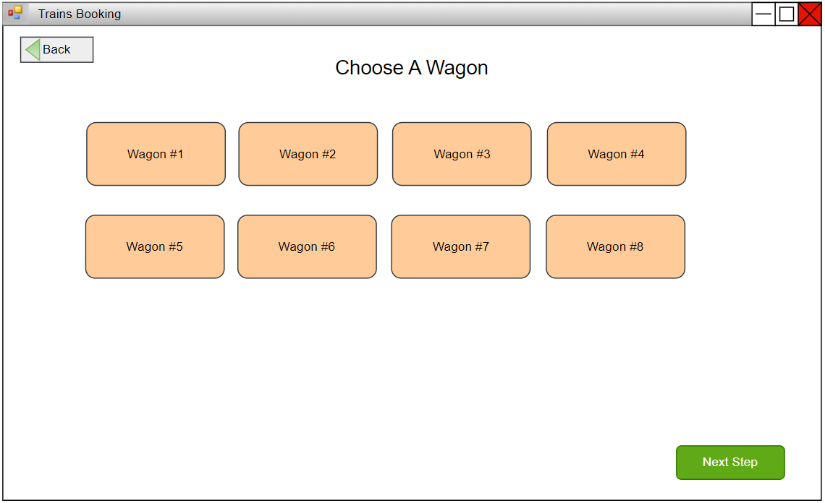

### 5.1.6. Screen “Book Seat”

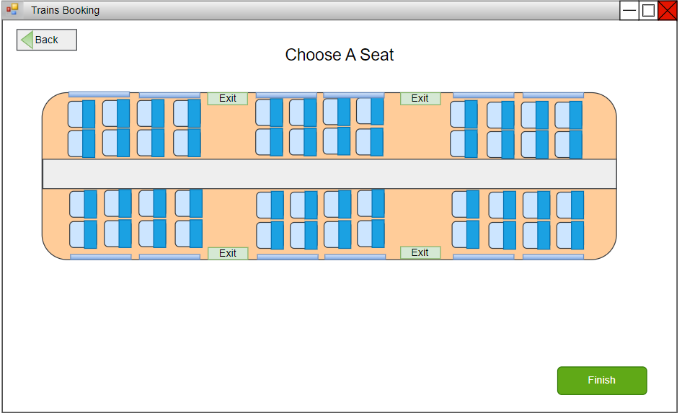

### 5.1.7. Screen “My Ticket”

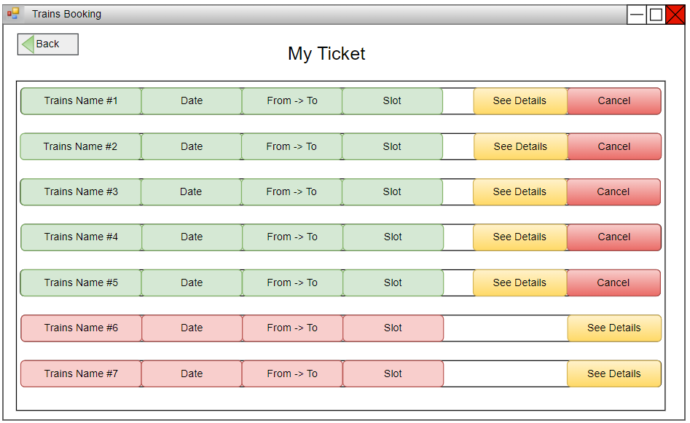

## 5.2 Interface Flow Diagrams (p. 51)

